**Wiring the microSD Card Reader Breakout Board:**

Using the LoRa shield, Arduino Mega, and SD breakout board pinout mappings, determine the connections that need to be made. Figures 1,2, and 3 show the specific pinout locations of both devices. The digital out connection from the SD card breakout can be put anywhere on a free digital output pin, either on the LoRa shield or the Mega itself. Only connect the VCC pin to 3.3V! 5V will damage the board.

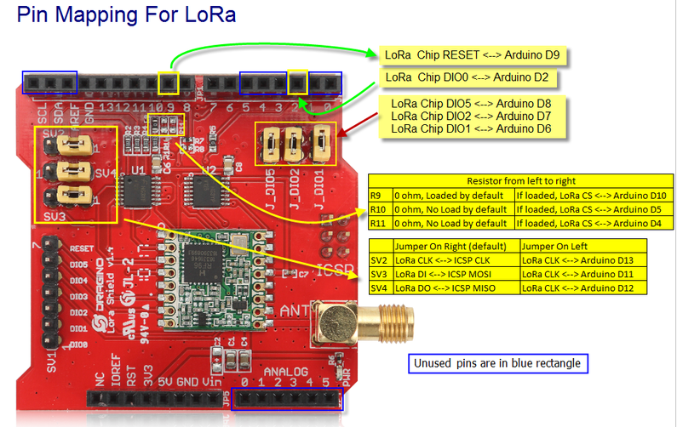

Figure 1: LoRa shield v1.4 pinout. Source: wiki.dragino.com

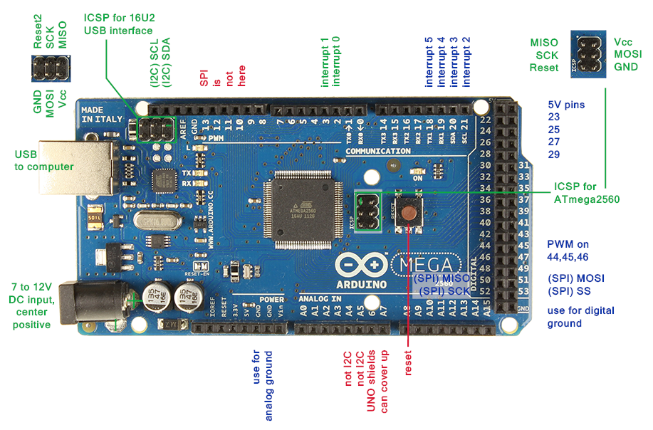

Figure 2: Arduino Mega 2560 pinout reference. Source: arduino-info.wikispaces.com/MegaQuickRef

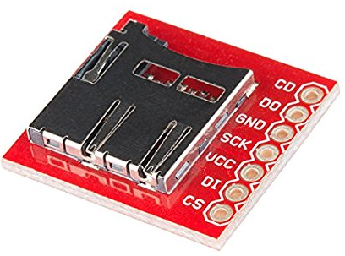

Figure 3: BOB-0054 microSD breakout board from SparkFun.

**BOB-0054 Pinout:**

CS – either pin 0,1,3,4, or 5 on LoRa shied (DigitalOut cs)

DI – pin 51 on Mega (SPI-MOSI)

VCC – *3.3V* VOUT

SCK – pin 52 on Mega (SPI-SCK)

GND – GND

DO – pin 50 on Mega (SPI-MISO)

CD – not connected

**Testing the microSD Card Reader Breakout Board:**

The SD card library reference needs to be added to the Arduino script header. The selected pin for the CS port must be programmed correctly for the breakout to work. Once all connections have been made on the breakout board to the LoRa shield and Arduino Mega a test sketch is recommended. This will ensure that all functions of the SD card are working correctly.

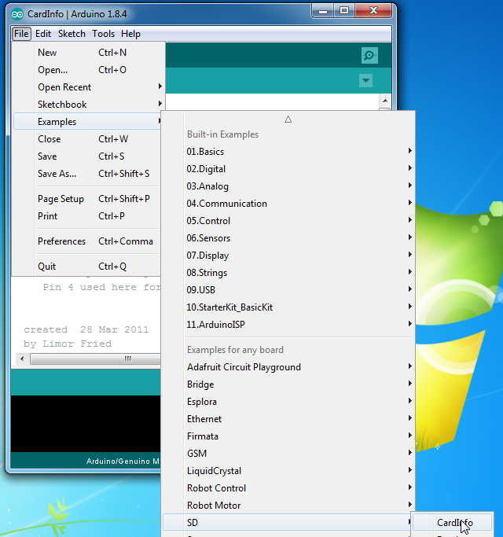

Figure 4: CardInfo test sketch for testing SD card functionality.



Figure 5: chipSelect integer variable must be changed from the default 4 to 1(or whatever pin was selected)

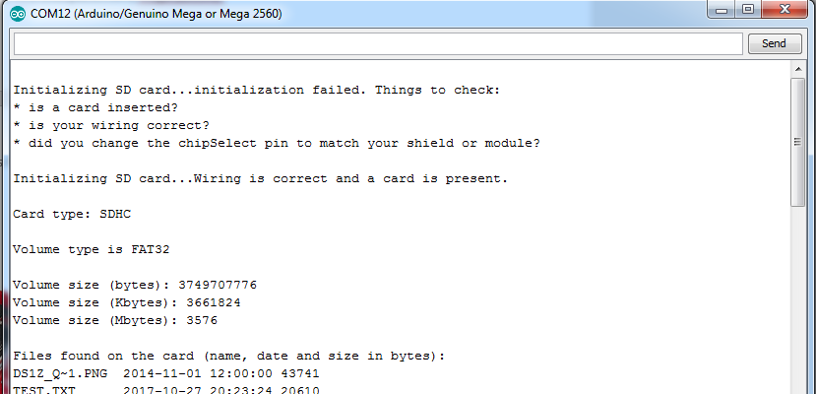

Figure 6: Successful serial print of the inserted microSD card. Initially this failed for me and I switched out the microSD card to another microSD card and it worked. The reader is sensitive to formatting and Arduino literature recommends reformatting if an error occurs. I formatted the problematic card and it worked.